Contents

1. Introduction 2

2. Pre-Installation preparation 3

2.1. Sensor hole drilling in tank 3

2.2. Fuel Installation work process diagram 4

2.3. Wiring diagram 4

2.4. Calibration Table 5

2.5 Installation Tools 5

2.6. Safety Guidelines 6

2.7. Check Fuel Quality 6

3. Sensor ID Configuration 7

3.1. Sensor ID Configuration in Power Center 7

3.2. Sensor ID Configuration on Corona TR7Z 9

4. Sensor Mounting 10

5. Calibration Process start 11

6. Tube, Open Air & Tank measurements 12

9 Calibration table configurion in Zon Control 20

10. Calibration Validation 25

11. Calibration Accuracy Test 27

# Introduction

Fuel Sensor measures in real time the amount of fuel in the Fuel Tank. The fuel is essential for the Generator operation.



We have two types of the fuel sensors in use

* Pressure fuel sensor
* Capacitive fuel sensors

It is important to know what type of fuel sensor and what shape of tank you are installing for precise calibration process. For each scenario, there is a dedicated Calibration Table (will be detailed later in the document).

1. The Pressure Sensor is now more widely used because of its ability to work with fuel with traces of water and dirt, but not sludge.
2. The capacitive sensor is more prone to failures in water and dirt conditions.

Both types of fuel sensors have been tested and approved to give accurate fuel data.

• Hoykell

Fuel Tank Shapes:

• Rectangular

• Cylinder

• Vertical Cylinder

• Hexagonal

• The Fuel tank for Holykell installation should be minimal 30 cm

• Tank that is made from plastic is not supported for installation

• Holykell sensor can be installed on with Diesel fuel (other types are not supported)

|  |  |  |  |  |
| --- | --- | --- | --- | --- |
| Pressure –  Holykell | Rectangular | Cylinder | Vertical  Cylinder | Hexagonal |
|  |  |  |  |  |

# Pre-Installation preparation

Tank Measurement

Measure the tank and enter the values in the Calibration table (See section 2.5)

Choose carefully where to drill the fuel sensor installation hole.

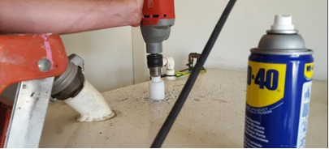

## 2.1. Sensor hole drilling in tank

Identify the hole location on the tank. Identify where the sensor will be installed in the tank to determine the hole to be drilled:

Look for existing holes that can be used. If not applicable, follow the below instructions:

• Preferably in the center of the tank hole

• As far as possible from the refueling hole. Make sure you are not damaging anything that is inside the tank

• If the center of the tank does not have space, choose an alternate position which is free enough to install

• Please ensure that there is room for drilling and installing the box for fuel sensor cover and protection box

• Accommodate for easy access for future maintenance work

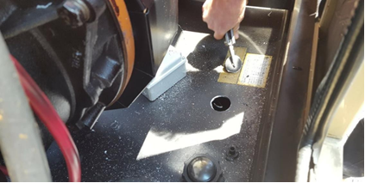

Drill a hole in the tank using the Electric Drill and Bi-Metal hole saw D=35mm at the selected location

## 2.2. Fuel Installation work process diagram

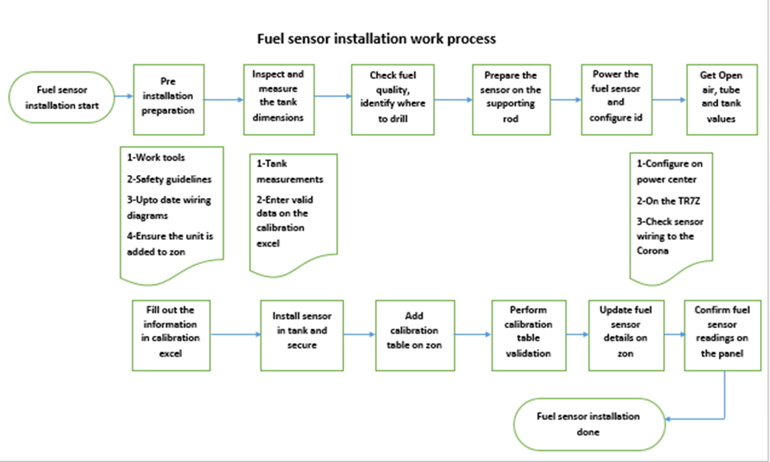

## Wiring diagram

You can download the most up to date wiring diagram from the [Support Portal](http://galoolitools.dnsalias.com/helpconsole6/Telecom-Customers/default.aspx?pageid=calibration_process)

See example of the K2 and TR5 Holykell fuel sensor wiring diagram:

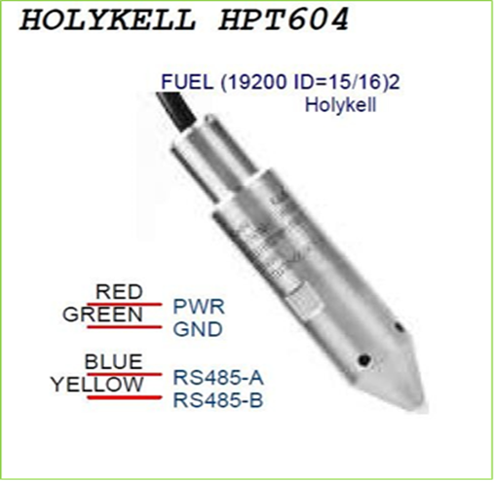

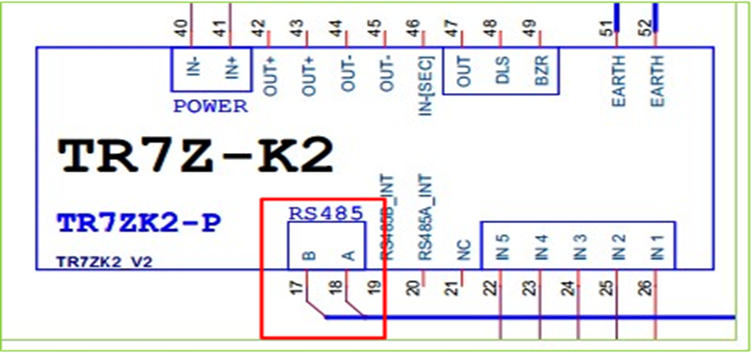

## 2.4. Calibration Table

Download the most up to date Excelfile from the [Support Portal](http://galoolitools.dnsalias.com/helpconsole6/Telecom-Customers/default.aspx?pageid=calibration_process)

Leave the Calibration table open through the entire installation, you will be required to fill in the fields

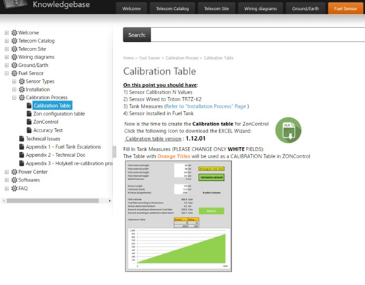

## 2.5 Installation Tools

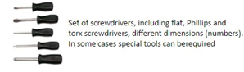

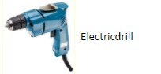

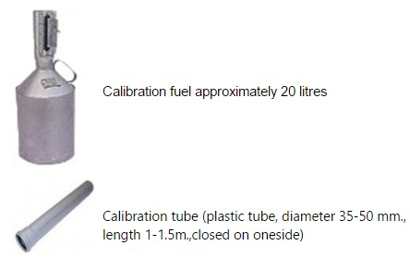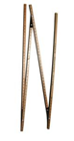

Stick for fuel measuring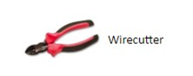

Computer Installed with Zon Control, Power Center, Internet connection, up to date Calibration Table

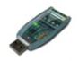 RS486 USB Converter

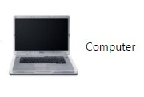

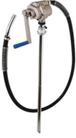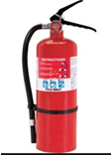

Fire distinguisher Manual Fuel pump

## 2.6. Safety Guidelines

Installation or replacement of Fuel Sensor must be done with extra care

• Fire extinguisher should be present throughout the entire Fuel sensor installation

• Wear Eye goggles, Safety boots and hand gloves

• Wear work clothes like overalls, Overcoats

• Prepare all work tools in advance

## 2.7. Check Fuel Quality

It is important that the fuel in the tank is clean, without water and sludge. Sludge isn’t accepted by Holykell sensors.

Two operational options to check fuel quality:

1. Use the Manual Fuel Pump to take a fuel sample to a different small transparent container

2. Lower Suction Tube inside the tank, suck the liquid, pull the lowest sample of the bottom of the tank, 1 liter is a good sample, in order compare how much dirt is in the tank

**Fuel sensor samples**

Clean Fuel Fuel with water Fuel with sludge

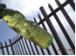  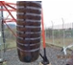

# Sensor ID Configuration

## 3.1. Sensor ID Configuration in Power Center

Configure the Fuel Sensor connected directly to the Power Center: Define Baudrate and ID to the sensor in the *Power Center* according to wiring diagram

• Connect the sensor to the *Power Center* using the 485 adaptor

• Connect the sensor to the Corona unit using the 4 wires: (

• Open Holykell Configuration Wizard

Red – 12 V Green – ground

Blue – A485 – connect to the adaptor to connect directly to the power center

Yellow – B 485 - connect to the adaptor to connect directly to the power center

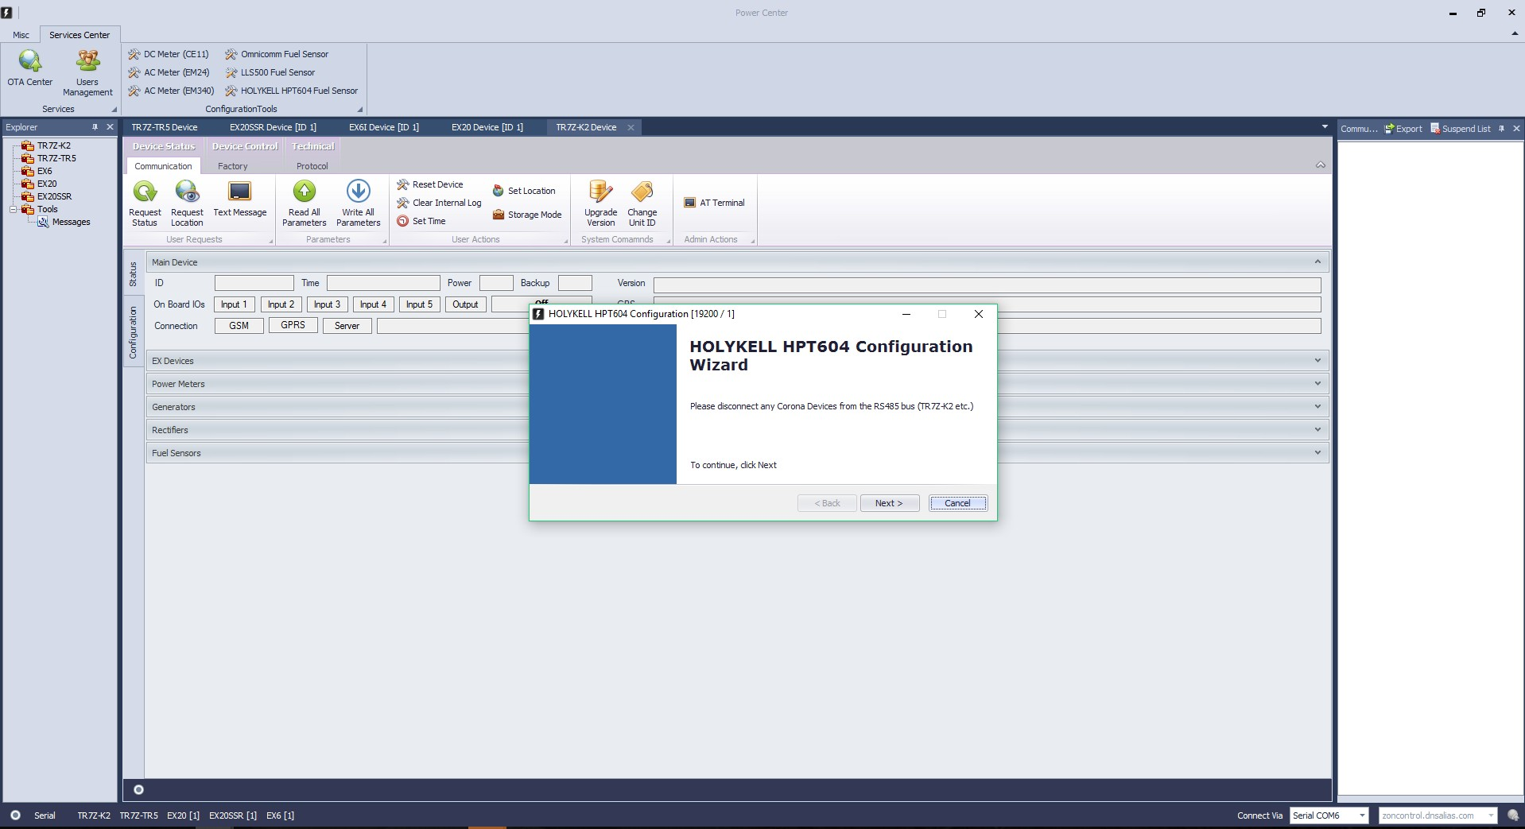

**Communication Baudrate** should be 19200

**Device ID**: ID Scan mode – the ID of the factory will appear (e.g. 1). You will need to update it to the

ID according to the Wiring Diagram (e.g. 16) and Apply

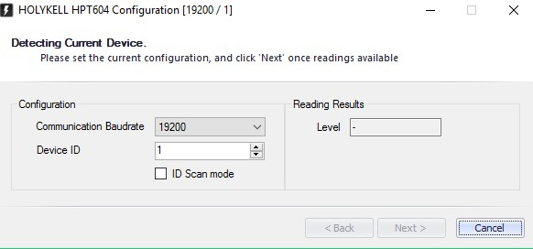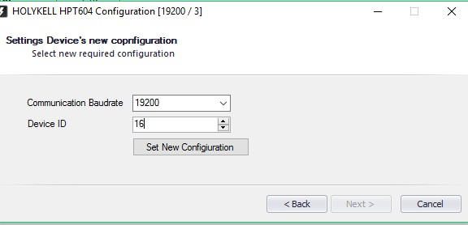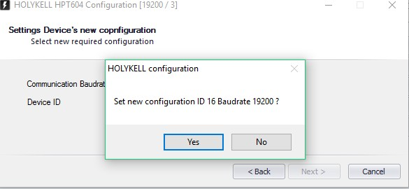

## 3.2. Sensor ID Configuration on Corona TR7Z

Connect the sensor to the Corona directly and configure the sensor ( to A, B 485 ports) Enter:

- Device

- Device ID

- Write all parameters

**Status** should show = 0 at this point

This field is very important – will show the updated N value of the fuel real time from the fuel tank during calibration and during ongoing operation

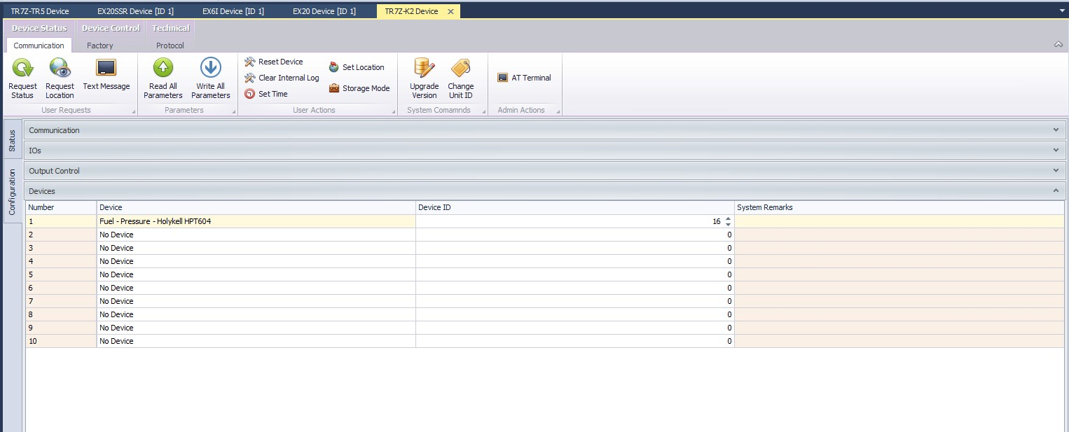

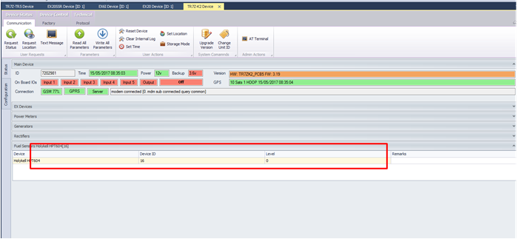



**Watch a Video of Drilling!**



20170426_103617.m p4

# Sensor Mounting

Measure the internal height of the tank, get a supporting copper rod with the same height of the internal height of the tank. Use cable ties, attach the sensor on the copper rod and make sure the fuel sensor **is 2 cm above** the supporting rod (Mount the sensor to the copper rod – Xcm above ground)

The cm depends on the sludge in the tank/customer specific requirement

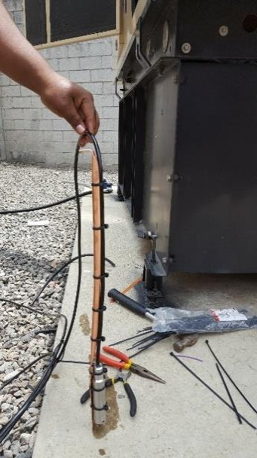

# 5. Calibration Process start

Open the **Calibration Table** – e.g. Fuel Sensor Pressure Holykell / Rectangular Tank

Fill in Section 1 – Administrative Details

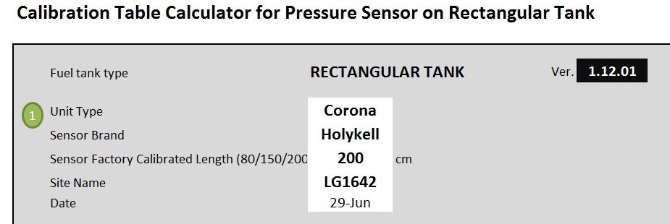

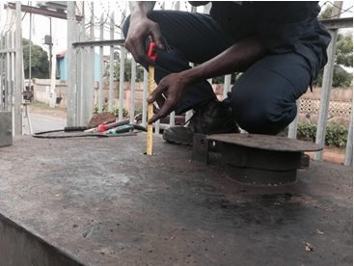

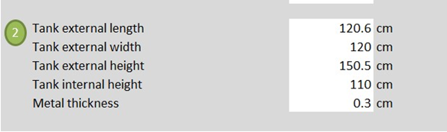

# 6. Tube, Open Air & Tank measurements

Perform measurements and enter the values to the Calibration Table as per sections 3+4 , and follow the instructions below:

Fill the external tube with fuel (should be full)

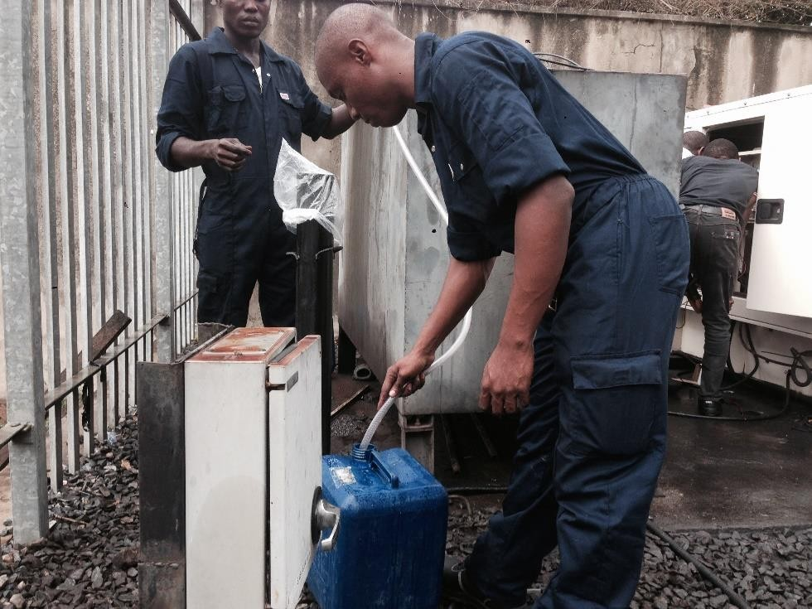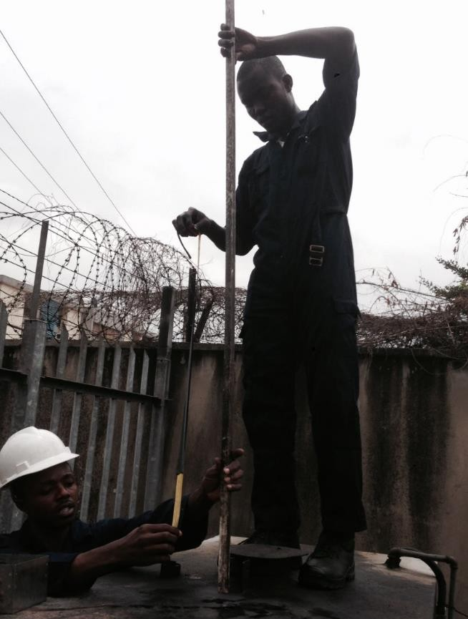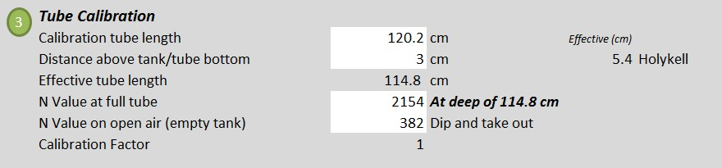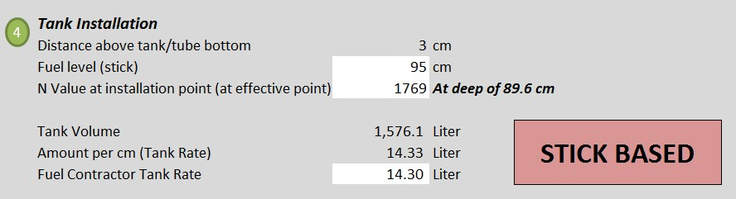

**N Value of full tube** - Enter the coper rod with the sensor to the tube and enter the N value shown in

the power center under “level” field

**N Value on open air (empty tank)** – take out the mounted sensor, hold it vertically, fill in the N value of open air taken from the power center “level” field

**Fuel level (stick)** – enter the stick to the tank and measure the fuel, enter the value in the table

**N Value at installation point (at effective point)** – deep the fuel sensor to the tank and receive a

value in the power center “level” field, enter the value in the table

**Fuel Contractor Tank Rate –** Contractor should provide this info. If not enter the same values as

Amount per cm (Tank Rate)

**Sensor mounting in the tank & box cover**

Drill holes on the box and mount it on the tank sensor hole

This procedure may vary according to the type of box

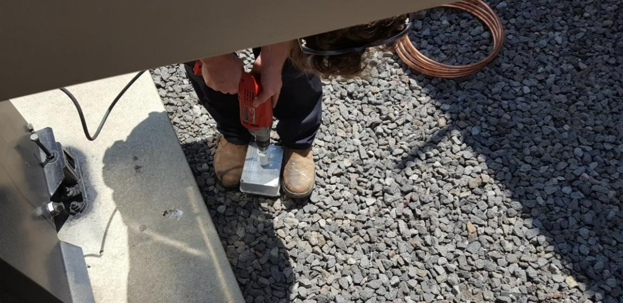

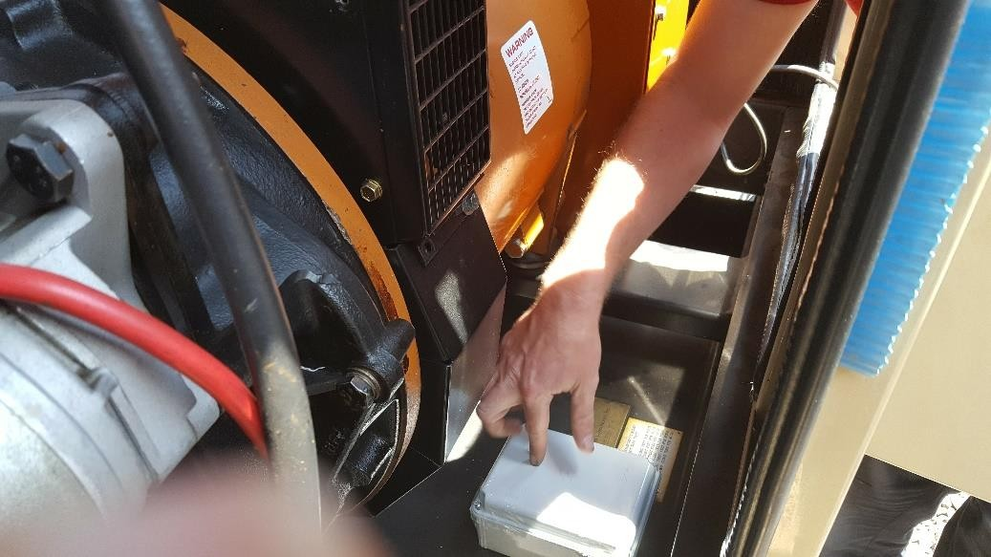

# 9 Calibration table configurion in Zon Control

Login to Zon Control > System > calibration

Select Add to enter a new table

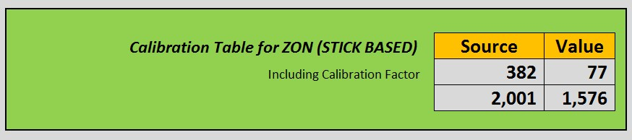

**Dimension**: *Volume*

**Fuel Mode:** Generator Medium

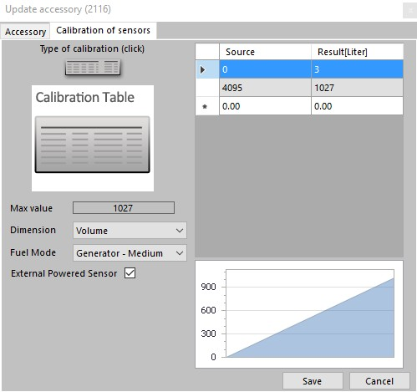

Zon Control > double click on Unit/Site > IOs > open Fuel Main Fuel

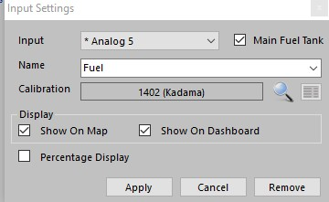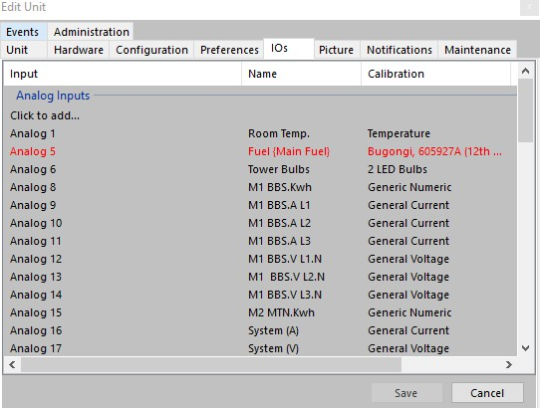

Select the Site Calibration table from the list:

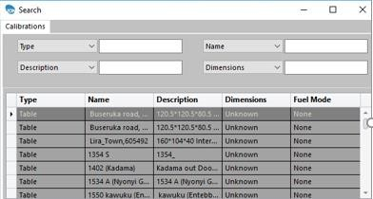

**Apply** to save the table in the Zon

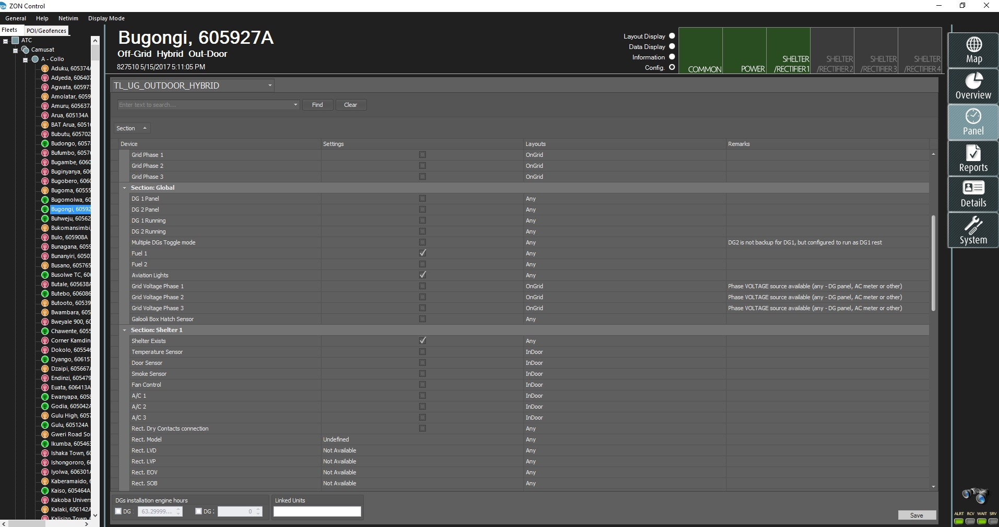

Fuel parameters to be configured in the Zon:

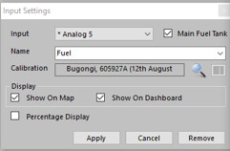

# 10. Calibration Validation

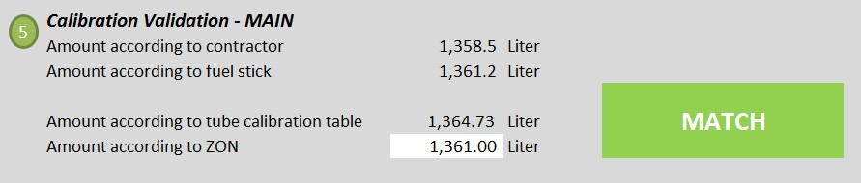

View Fuel level in the Panel dashboard:

*Amount according to Zon* - Enter the value shown in the Zon Panel to the calibration. You should get a

MATCH (green)

*Note:* if receive a RED match, go back to the installation steps and validate again your steps

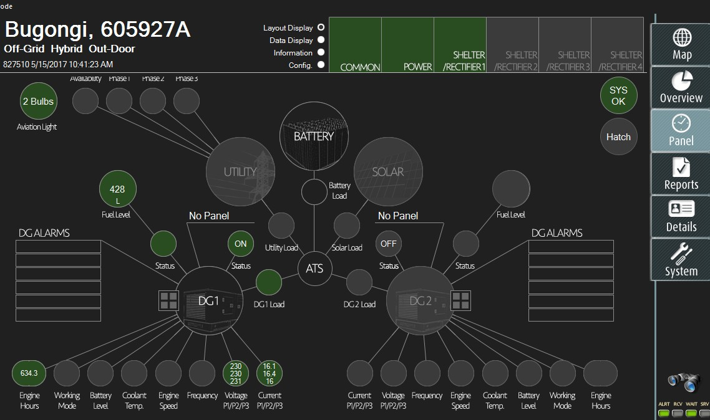

# 11. Calibration Accuracy Test

Calibration table – section 6

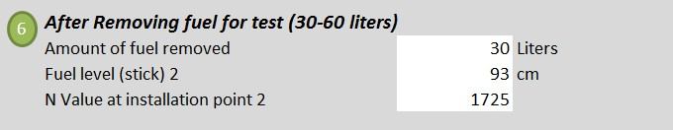

***Amount of fuel removed*** - Take a precise measured quantity of fuel out from the tank aside: 40 liter

***Fuel level (stick) 2*** - Deep the stick in the tank and measure the quantity of fuel

***N Value at installation point 2*** – power center N value “level”

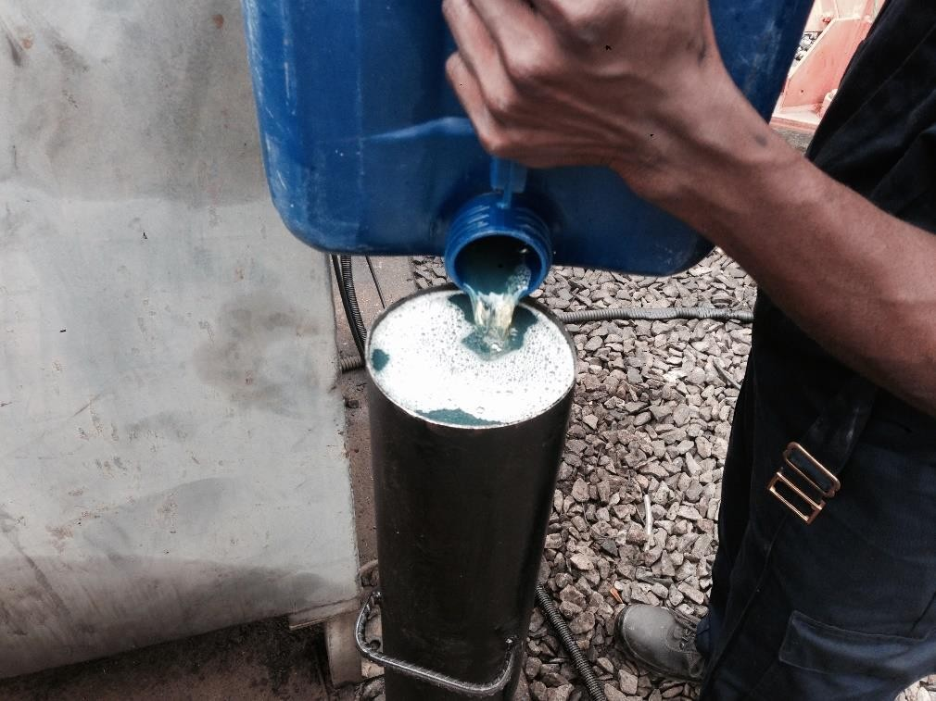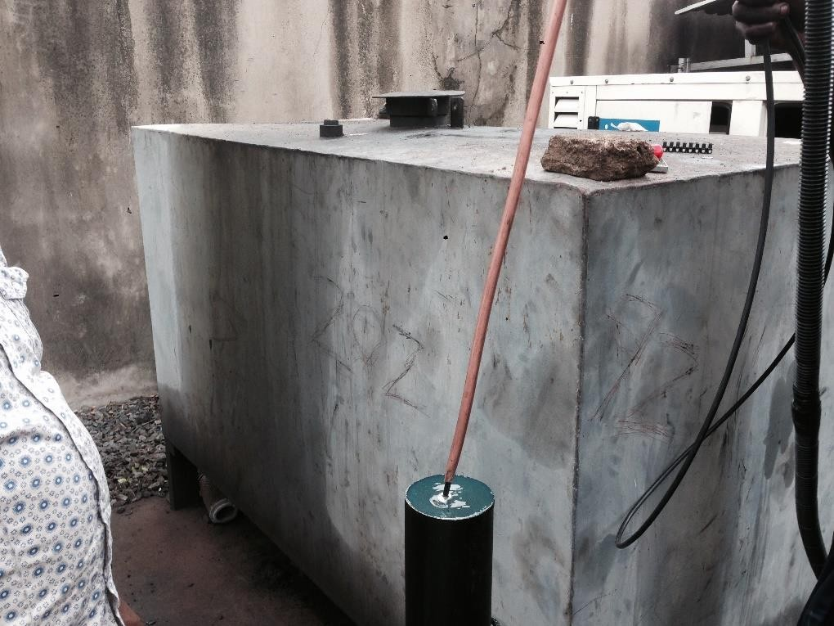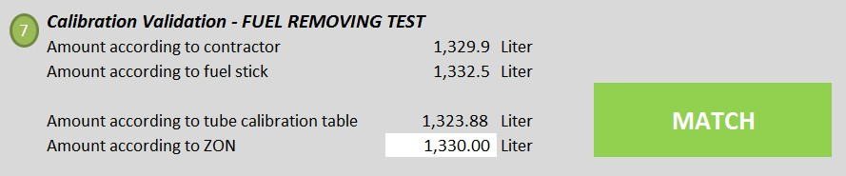

***Amount according to ZON*** – Enter the number appearing in the panel (it will calculate automatic the

*amount in the Zon* minus 40 litres defined in the *Amount of fuel removed*) You should receive a green MATCH at this point

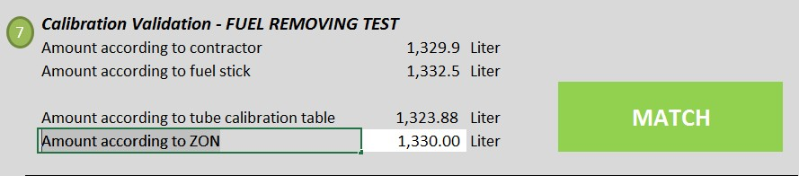

**12. Fuel Sensor Zon Control - Panel Analyse**

Fuel events & alarms

Status – displays if Fuel sensor ins connected/disconnected